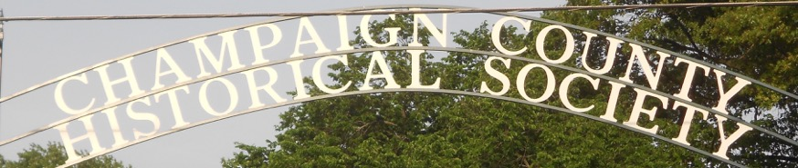
Est. 1934 July/August 2018
CHAMPAIGN CHRONICLES
809 E Lawn Ave Urbana, Ohio 43078 www.champaigncountyhistoricalmuseum.org

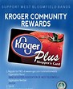
KROGER COMMUNITY REWARDS PROGRAM

Did you know that YOU can help us by registering? Simply register online at krogercommunityrewards.com and a small donation will be made to the Champaign County Historical Society every time you use your Kroger Plus card.

Registration directions are printed at the end of this newsletter for your convenience.
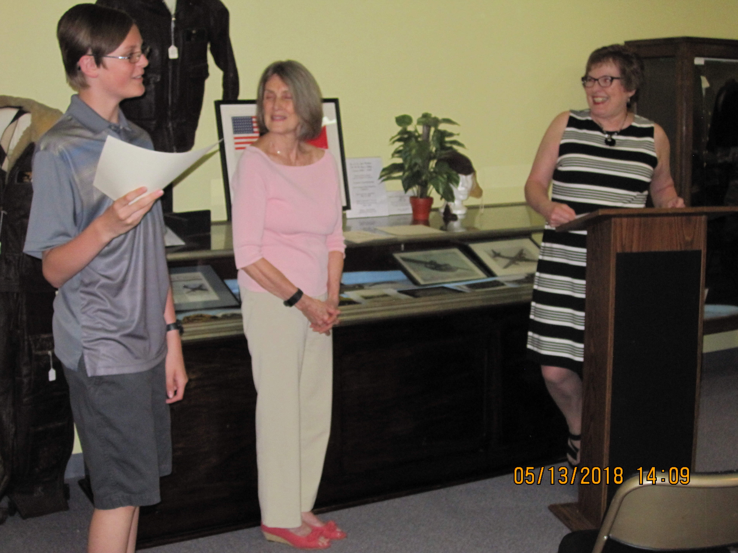
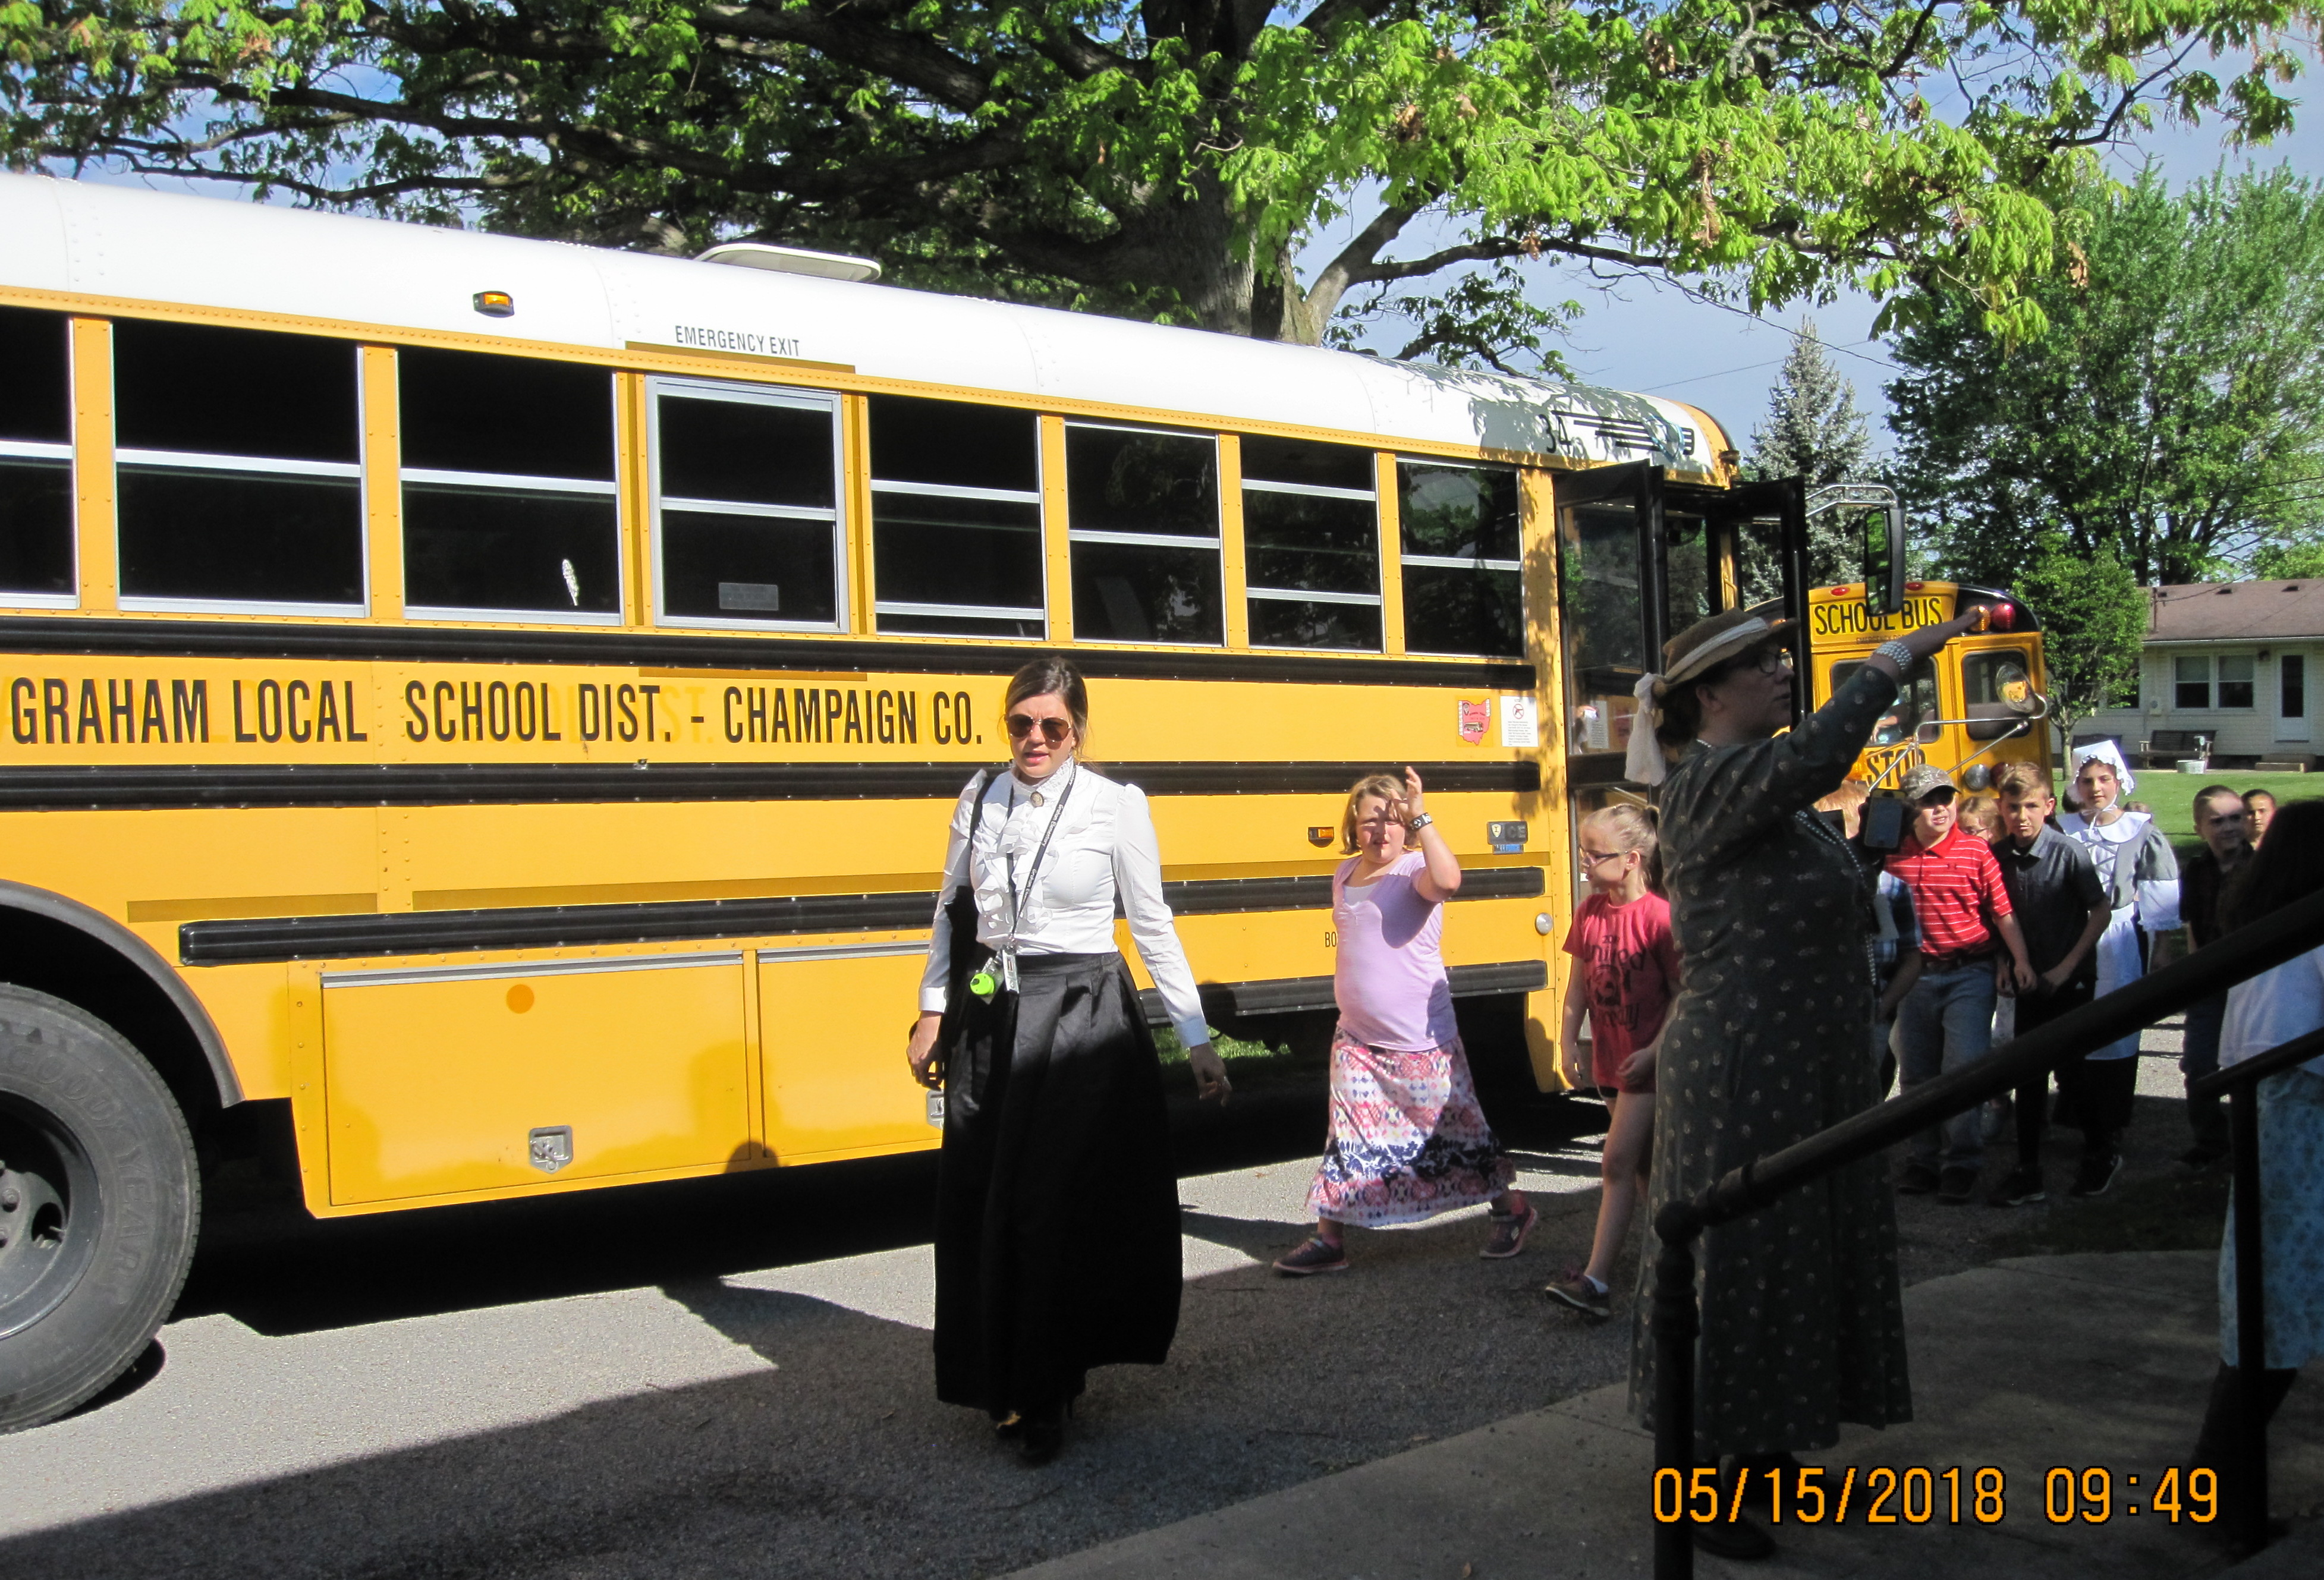
On Sunday May 1 3 the Champaign County Historical Society recognized state finalists in the National History Day competition during a special program at the museum. Educational Outreach Chair Terri Marratta, assisted by Cheryl Walter, descendant of Judge Middleton, presented the Judge Evan P. Middleton award to all finalists who also received a one-year membership to CCHS.
EDUCATIONAL OUTREACH !

Students receiving awards were Zoey Cahall, Bryant Chamberlain, Rylie Daniels, Paige Deere, Henry Harrigan, Raegan Hepp, Michael Holland, Hannah Louck, Paige Martinez, Gatlin Ridgwell, Anna and Stephanie Selvaggio, Bree Stouffer, Lily Talebi, Grace Ullom, and Jenna Weimer.. As awards were presented each student informed the audience of the nature of his or her project. One student, Bryant Chamberlain, a UJHS 7th grader (pictured), has been chosen to represent Ohio at the National History Day competition to be held at the U. of Maryland in June. His project focused on the Toledo War. All Champaign County schools were invited to participate.

On May 15 and 16 Graham third grade students accompanied by their teachers - all dressed in period clothing - toured the CCHS museum. The occasion was "1800’s Day" during which students learned what life was like for those who lived in Champaign County over 100 years ago.

On May 24 Tom Smithhisler and guests from Downsize Farms toured the museum. They enjoyed the presentation and appreciated that our facility is accessible to the handicapped.

One of the missions of the Educational Outreach committee of the Champaign County Historical
Society is to supplement and enrich the social studies curricula of Champaign County schools by
serving as a resource to teachers by offering in-depth lessons and speakers on specific topics in
Champaign County history.

Currently the committee is soliciting information on Addison White of Mechanicsburg and the
Underground RR activity in Champaign County. Anyone with particular knowledge of the county
in this antebellum period of history who is willing to contribute to this project is encouraged to
contact: Terri Marratta, CCHS Ed. Outreach Chair wmarratta@woh.rr.com 937-653-5030.
President’s Update

Our organization continues to march forward in a number of areas including the cyber world. Our website - www.champaigncountyhistoricalmuseum.org - exhibits ongoing innovation and improved accessibility, and our facebook page is receiving a record number of “likes.”

This is most timely in that the board of trustees voted on April 25 to place a levy for “maintenance and operation” on the November ballot. As before, the levy is for 0.3 mil (3/10ths) for 5 years which would cost a Champaign County property owner about $10/year on a $100,000 property. We were only 439 votes short the last time, and we are mounting a maximum effort to pass it so that we can hire full-time staff, something most organizations of a similar nature have already accomplished; in the meantime we continue to seek volunteer assistance.

What will we do differently this time? We know that we need to reach out to younger voters, particularly in the county, and our new electronic capabilities will help us do that. Since last November we have worked steadily to bolster our presence in the community by recruiting and training volunteers to open the museum on Sundays, engaging the county schools more often and efficiently, posting Ward Lutz’s “Then and Now” and “Looking Back” items in the newspaper and on facebook, presenting monthly programs of interest, and speaking to local groups. Moreover, Ken Wright’s Community Outreach committee is hard at work establishing partnerships in an around the villages.

The Levy Committee begins weekly meetings in June and will work diligently right up to Nov. 6. More than ever, we’ll need the support of all members to pass this issue and thus stabilize our museum operation. Contributions made to the CCHS Campaign Committee will be deposited in the First Central National Bank of St. Paris and may be sent to CCHS, P. O. Box 65, Urbana, OH, 43078. Thank you for your support!

-Dan Walter

COMING EVENTS

On Sunday July 8 at 2:00 pm longtime DJ and historian DICK HATFIELD (aka The Imperial DeBubba) will present his recollections of The Coconut Lounge. If you hear the drum intro to “Sherry” and burst in to song - or wonder about those who do - you’ll not want to miss this trip down memory lane when the Four Seasons, Beach Boys, and 35 other top bands appeared between April 1963 and Jan. 1965 at this nightclub on the Upper Valley Pike right here in Champaign County. Come and share your stories with others!

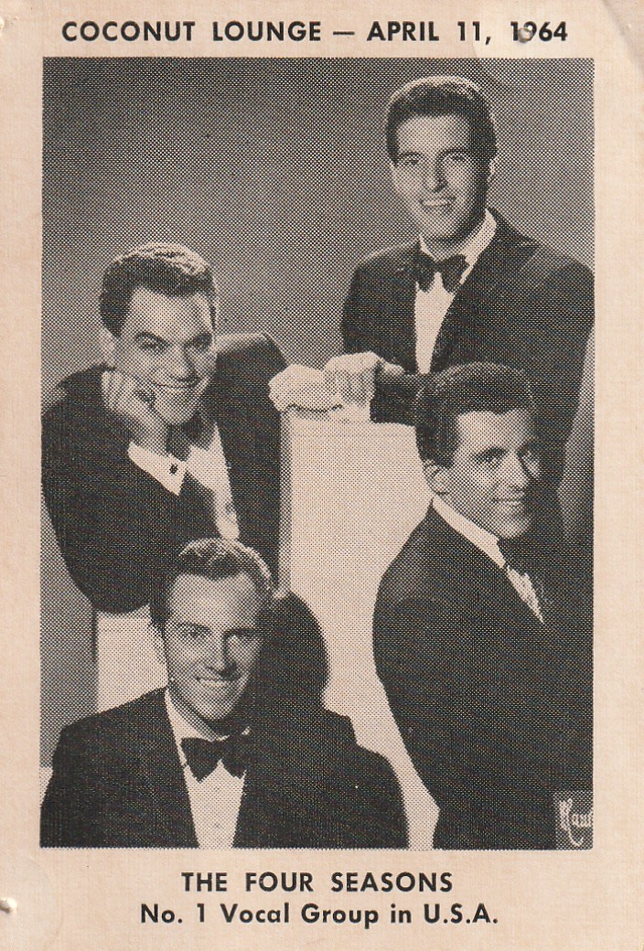
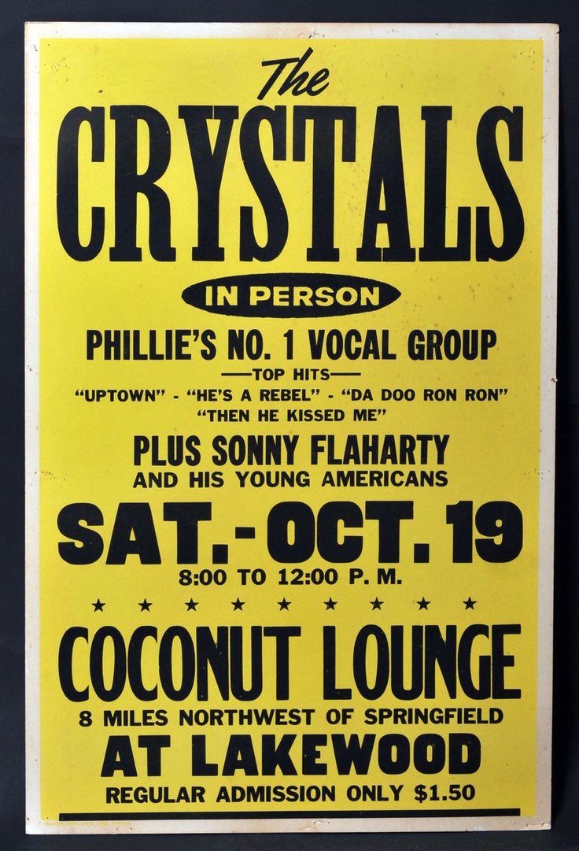

On Sunday Aug. 19 at 2:00 pm DALE THORNTON, who was born and raised in St. Paris, will present the history of that “warm and friendly town” which was founded in 1831. The presentation will include photos such as this downtown scene from Dale’s personal collection.
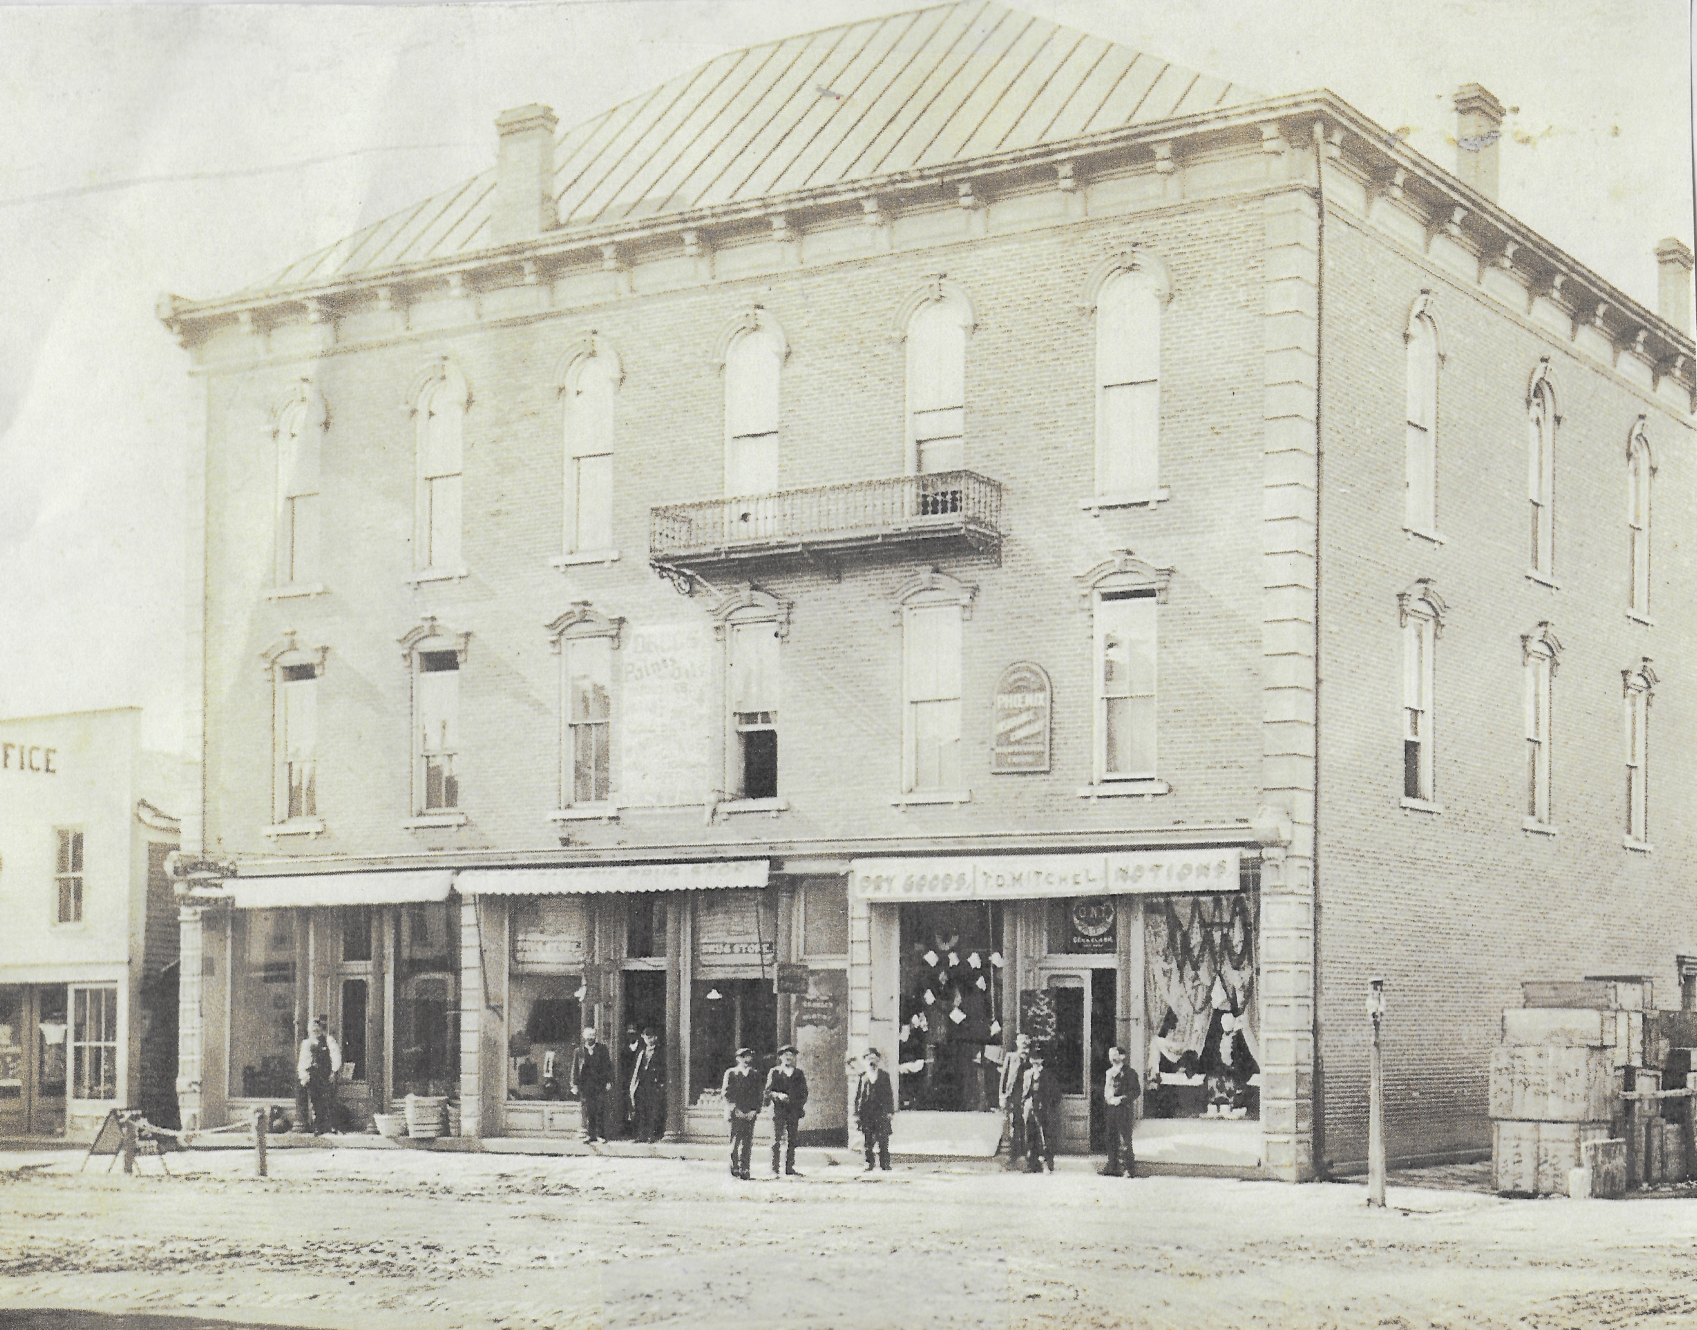

New Members

Ray & Sandra Branstiter Paige Martinez
Zoey Cahall Tom & Pat Rezack
Bryant Chamberlain Gatlin Ridgwell
Rylie Daniels Anna and Stephanie Selvaggio
Paige Deere Tammy & Ferran Shabbis
Henry Harrigan Jim & Irene Short
Gregory & Jennifer Harvey Robert Spry
Raegan Hepp Wayne & Linda Smith
Charles & Lydia Hess-Greer Bree Stouffer
Michael Holland Lily Talebi
Tom Keller Grace Ullom
William & Diane Kremer Drs. Greg Wagoner and Bill Bean
Hannah Louck Jenna Weimer

Invite your friends! www.champaigncountyhistoricalmuseum.org

TO USE THE KROGER COMMUNITY REWARDS PROGRAM TO BENEFIT THE CHAMPAIGN COUNTY HISTORICAL SOCIETY:

- Register online at krogercommunityrewards.com and have your Kroger Plus card handy. Click on Sign In/Register.
- Most participants are new “online” customers, so click on SIGN UP TODAY in the ‘New Customer” box.
- Sign up for a Kroger Rewards Account by entering zip code, clicking on favorite store, entering your email address and creating a password, agreeing to the terms and conditions.
- You will then get a message to check your email inbox and click on the link within the body of the email.
- Click on My Account and use your email address and password to proceed to the next step.
- Click on Edit Kroger Community Rewards information and input your Kroger Plus card number. Update your information.
- Enter our NPO number (72139) or the name of our organization (Champaign County Historical Society).
- To verify you are enrolled correctly, you will see our organization’s name on the right side of your information page.
- REMEMBER, purchases will not count for our group until after members register your card(s).
- Do you use your phone number at the register? Call 877-576-7587 to get your Kroger Plus card number if you no longer have your card or have forgotten it.
- Members must swipe your registered Kroger Plus card or use the phone number that is related to your registered Kroger Plus card when shopping for each purchase to count.
- Fuel points will not be affected.
- Thank you! It’s not that difficult!

