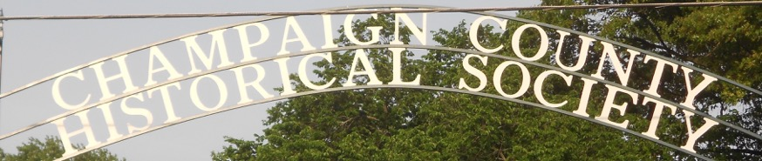
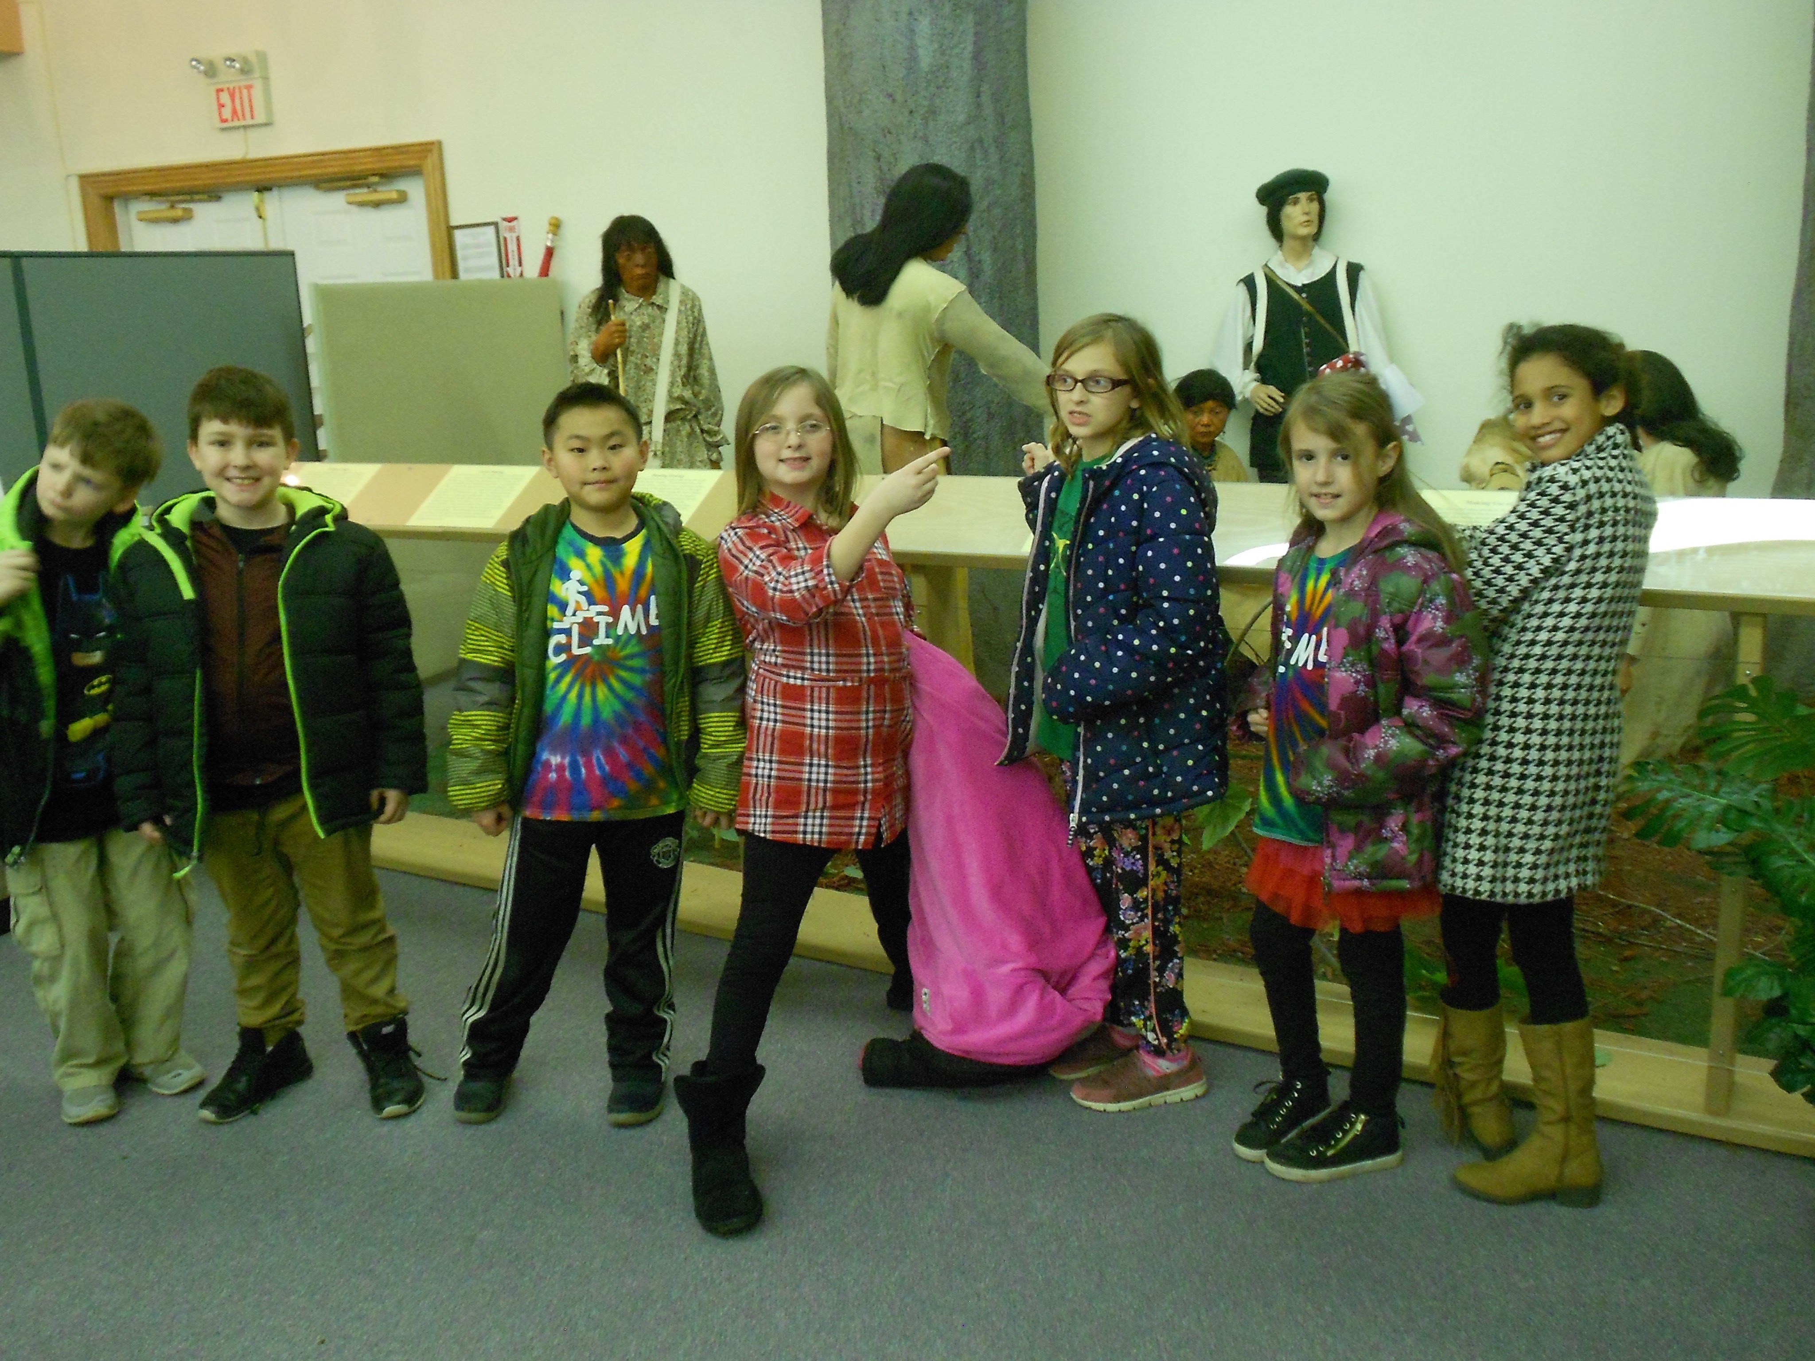
CHAMPAIGN CHRONICLES
Est. 1934 March/April 2018
EDUCATIONAL OUTREACH !
809 E Lawn Ave Urbana, Ohio 43078 www.champaigncountyhistoricalmuseum.org
Our museum continues to be a destination for elementary students from throughout the county, and we are also hard at work to bring “traveling” programs in to the schools. Pictured above are excited students from the “Y” who toured the museum in February. Paul Waldsmith, CEO of the YMCA (and new CCHS member), explains the program:

The Champaign Family YMCA is pleased to collaborate with the Champaign County Historical Society because it's a 'win-win' for both organizations. The children that the YMCA serves love to go to the Historical Society's museum for field trips. Thank you for facilitating the recent field trip taken by the Y's CLIMB program, a grant-funded after school enrichment program serving 2nd and 3rd grade s students at Urbana South Elementary.

President’s Update

Recently board officers have met with several organizations - the Chamber of Commerce and the YMCA to name two - with the idea of “partnering” for the common good. And in the weeks to come we shall explore additional such partnerships.

Moreover, to ensure that all township residents are aware of our efforts we have created a Community Outreach Committee. This Committee seeks to identify and recruit individuals from each township and village to become Township Advocates. TA’s will assist in communicating CCHS events, programs, membership drives, fundraising, requests for artifacts, photos, documents, etc. to their respective neighborhoods.

And we are proud to announce that in addition to Mondays and Tuesdays the museum will soon be open on Sunday afternoons from 1:00 - 5:00 pm. The first Sunday opening will be April 29.

However, in preparation for this move there is work to be done. We need existing or new members to serve as volunteer docents. To that end we shall be holding one-hour docent training sessions on the following Mondays: April 2, 9, 16, and 23 at 2:00 pm.

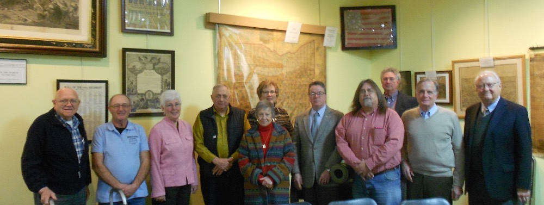
Members who would like to become docents or to volunteer in other capacities, perhaps as greeters, are encouraged to contact us by phone (653-6721) or e-mail (champhistmus@ctcn.net). - Dan Walter
MEET THE BOARD

Champaign County Historical Society Board of Trustees as pictured at the Annual Meeting held at the museum on January 21. R-L: Dan Gilbert, Norm Bowers, Nancy Donohoe, Charles Emory, Barbara Lehmann, Terri Marratta (Secy.), Rob Pollock (Vice-Pres.), Mark Gaver, Ken Wright (Treas.), Fred Krift (new), and Dan Walter (Pres.). Not pictured, new trustee Greg Shipley.
COMING EVENTS

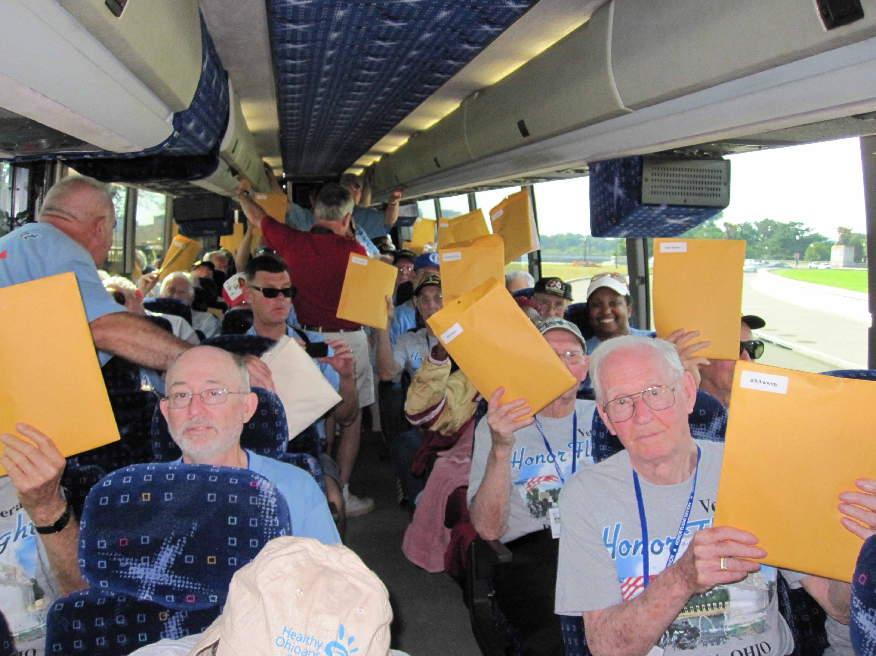
On Sunday March 18 at 2:00 pm Al Bailey will present a program about Dayton Honor Flight whose mission is to take veterans of WWII, Korean, and Vietnam Wars to see their national memorials in Washington, D.C. Veterans pictured are on the plane.

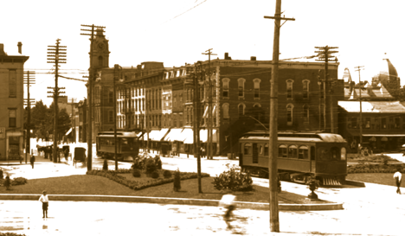
On Sunday April 22 at 2:00 pm noted historian and author Scott Trostel will present “ Springfield, Troy, and Piqua Railway,” the fascinating story of this rural interurban railway, a 30 mile line built between 1903 and 1904 by former Ohio Governor, Springfield’s Asa Bushnell.

New Members

George Bianchi Deerfield Beach, FL Rick Cartwright Piqua
Ann Greer Urbana Charles and Susan Hickey Mechanicsburg
Tim Kemper Woodstock Bill Smith Springfield
Paul Waldsmith Urbana

Invite your friends! www.champaigncountyhistoricalmuseum.org

