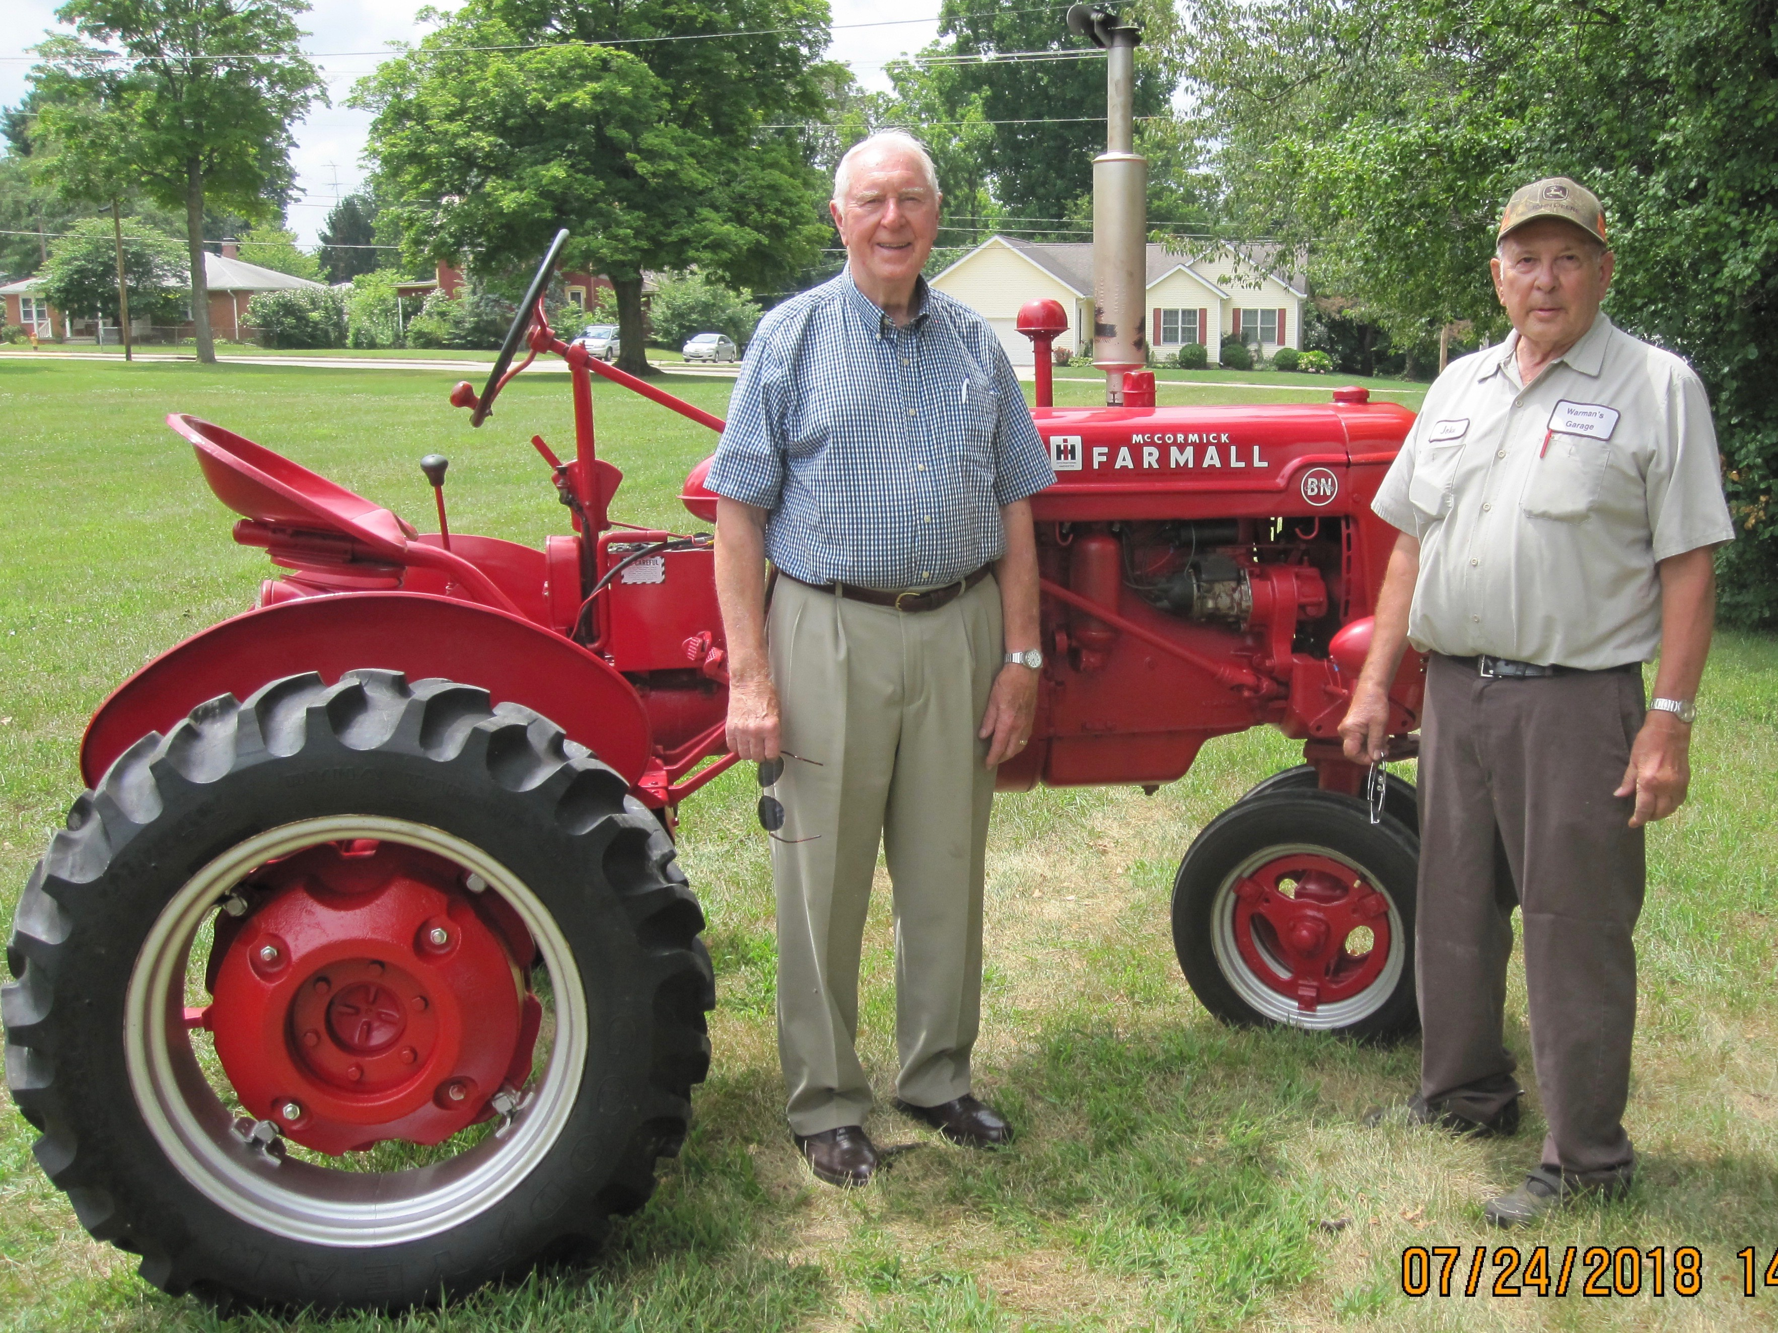
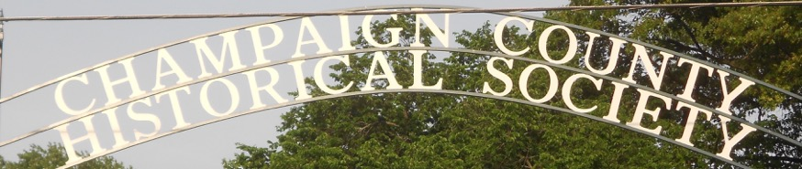
CHAMPAIGN CHRONICLES
809 E Lawn Ave Urbana, Ohio 43078 www.champaigncountyhistoricalmuseum.org
Est. 1934 September/October 2018
OUR NEWEST ACQUISITION !
In July members Joe and Cecily Morrow donated their prize tractor, a beautifully-restored 1943 McCormick-Deering Farmall BN. The restoration was done by Skip Merica. Joe is pictured on the left with Bill Warman who did the mechanical work and delivered the tractor. On the right volunteers prepare the Farmall for display as it enters the museum.
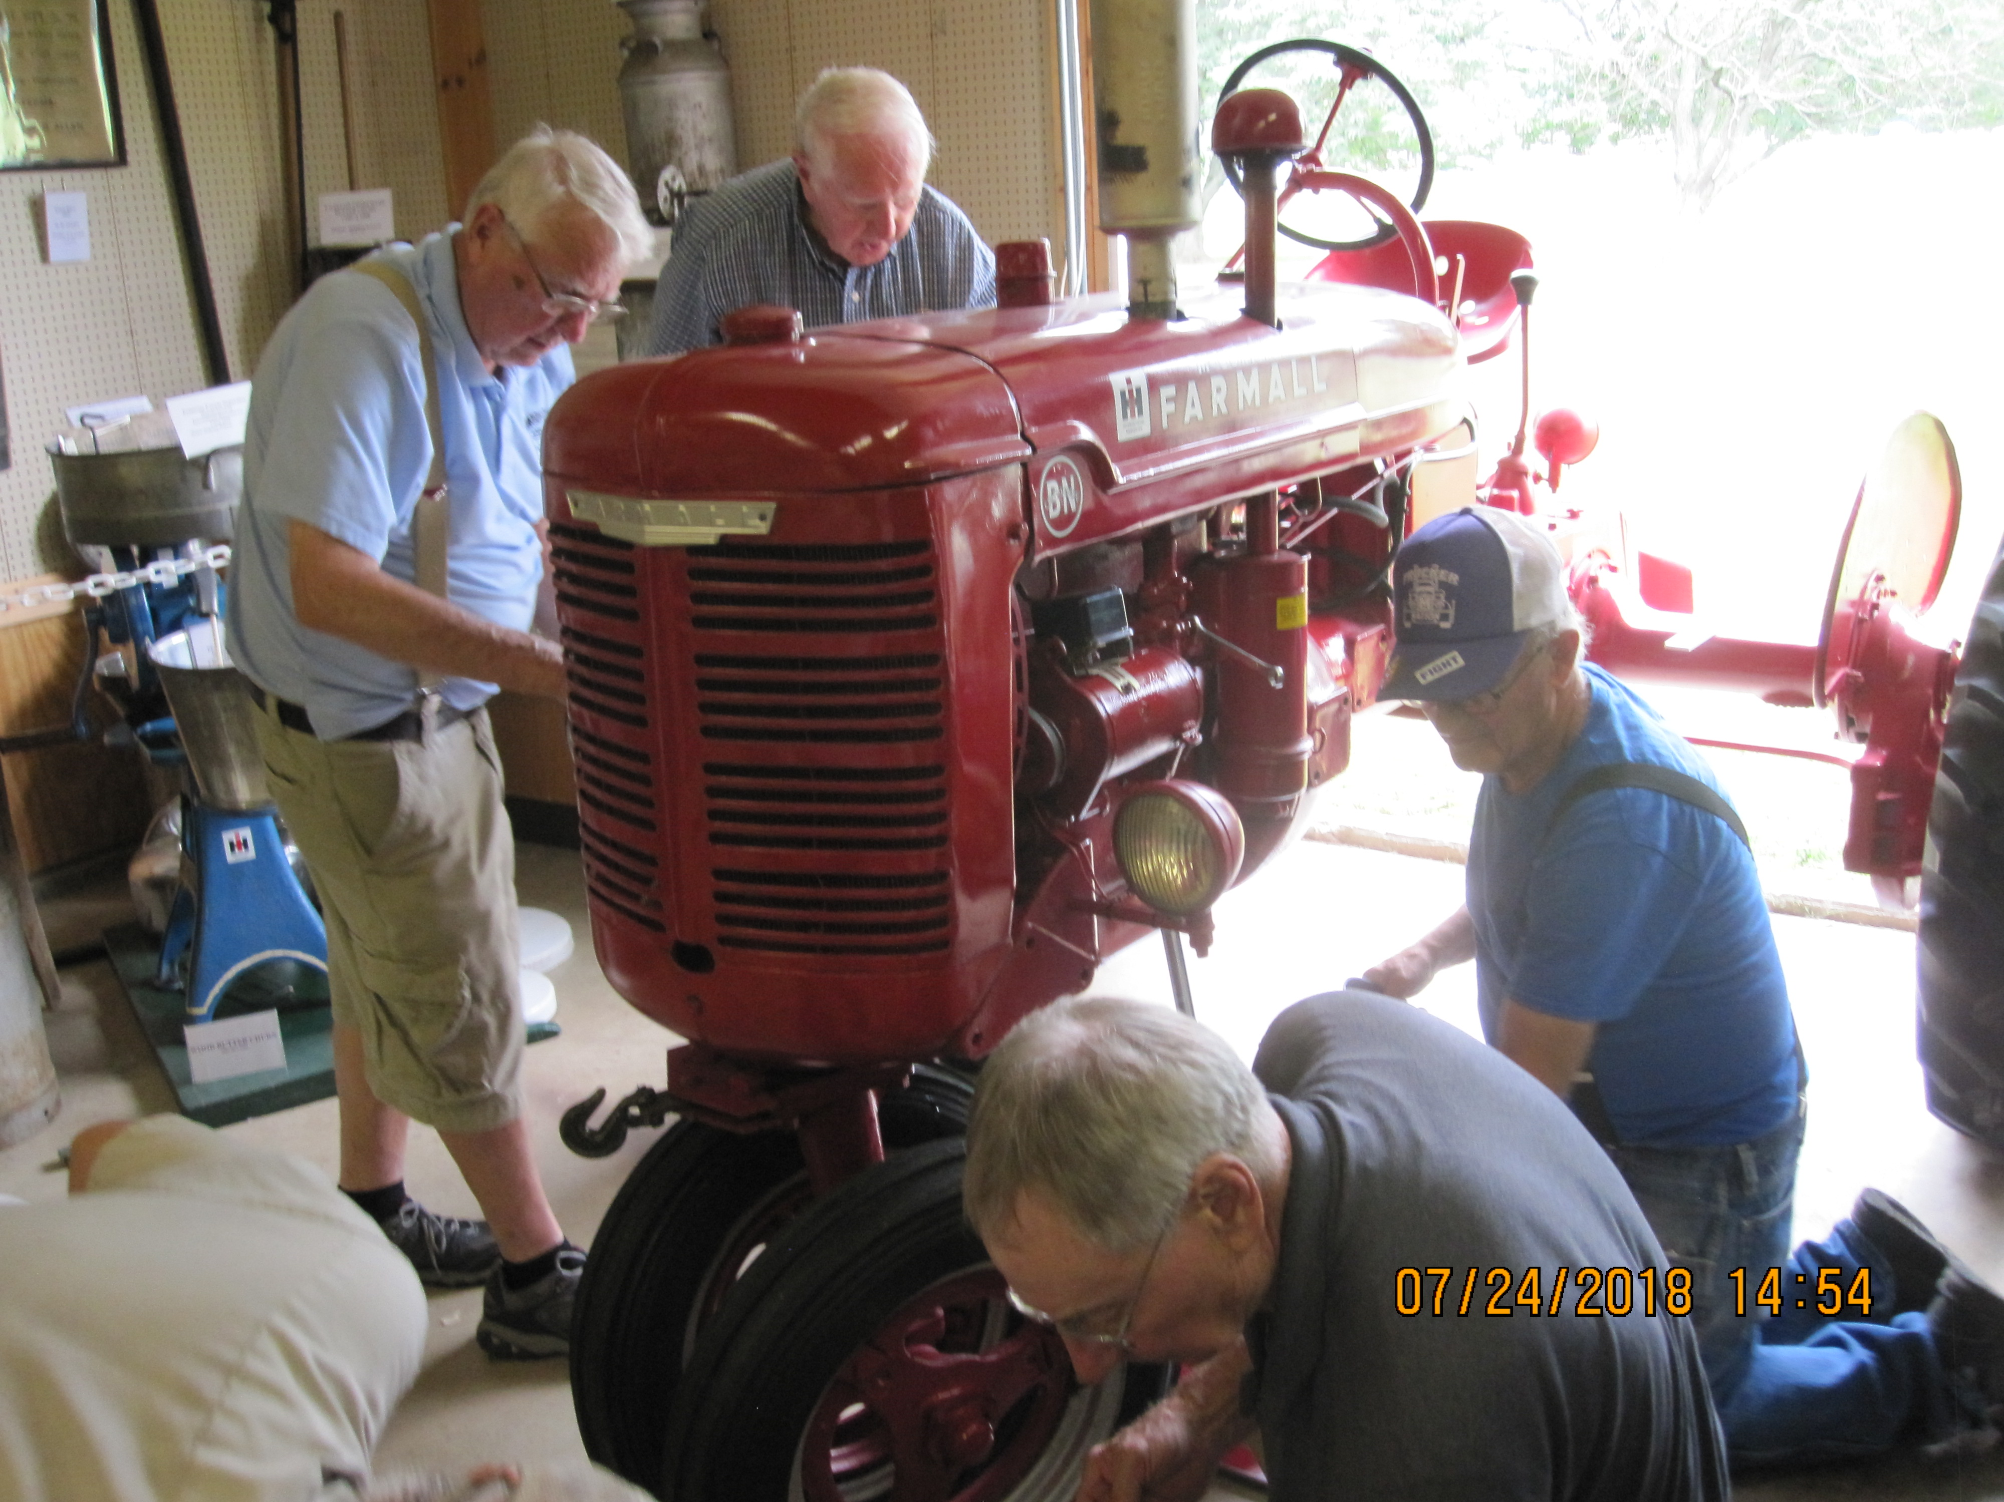
The 1943 Farmall is proudly featured in our museum which is open on Mondays and Tuesdays 1 - 4 and now Sunday afternoons 1-4. Plans are to enter it in the Hoopla Parade Sept. 29 with Joe Morrow himself at the controls.

CHAMPAIGN COUNTY FAIR
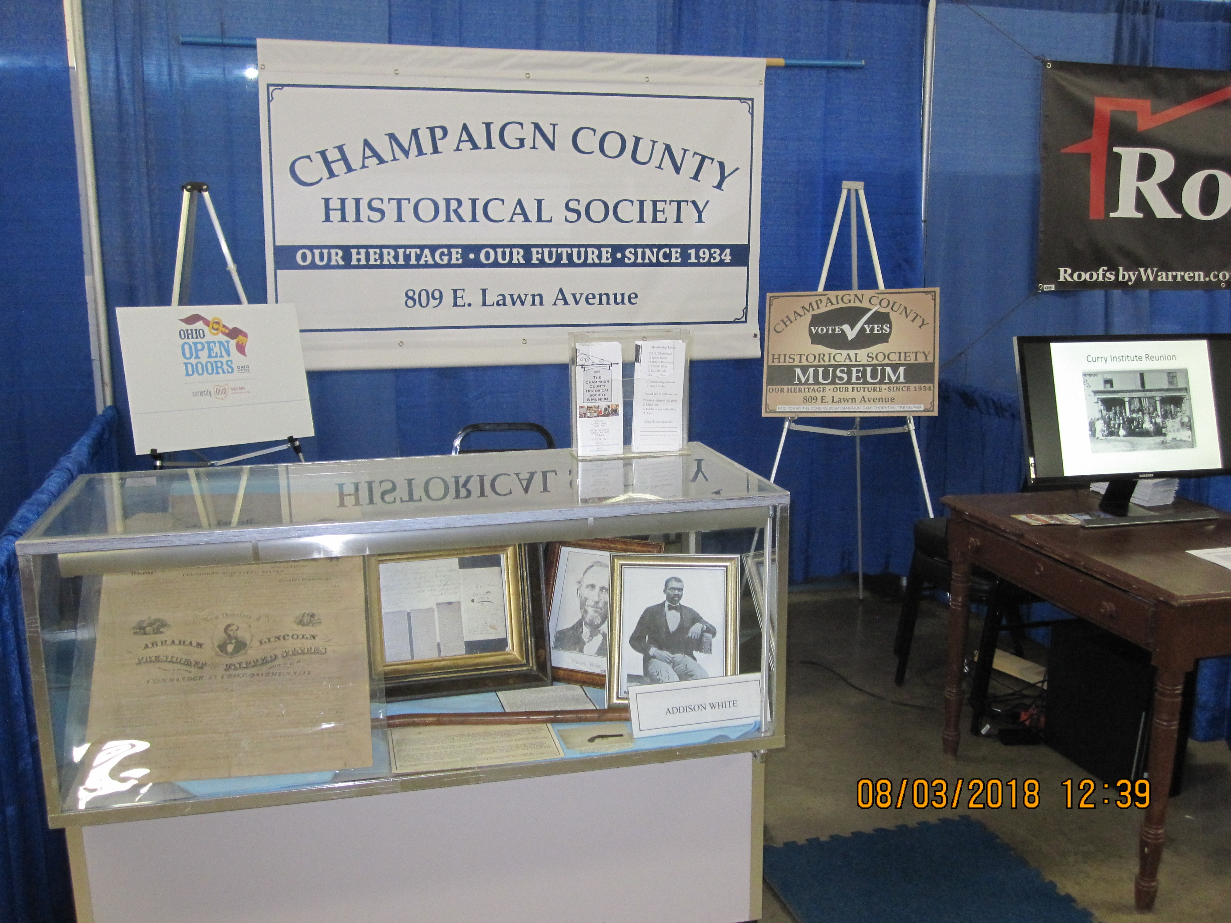
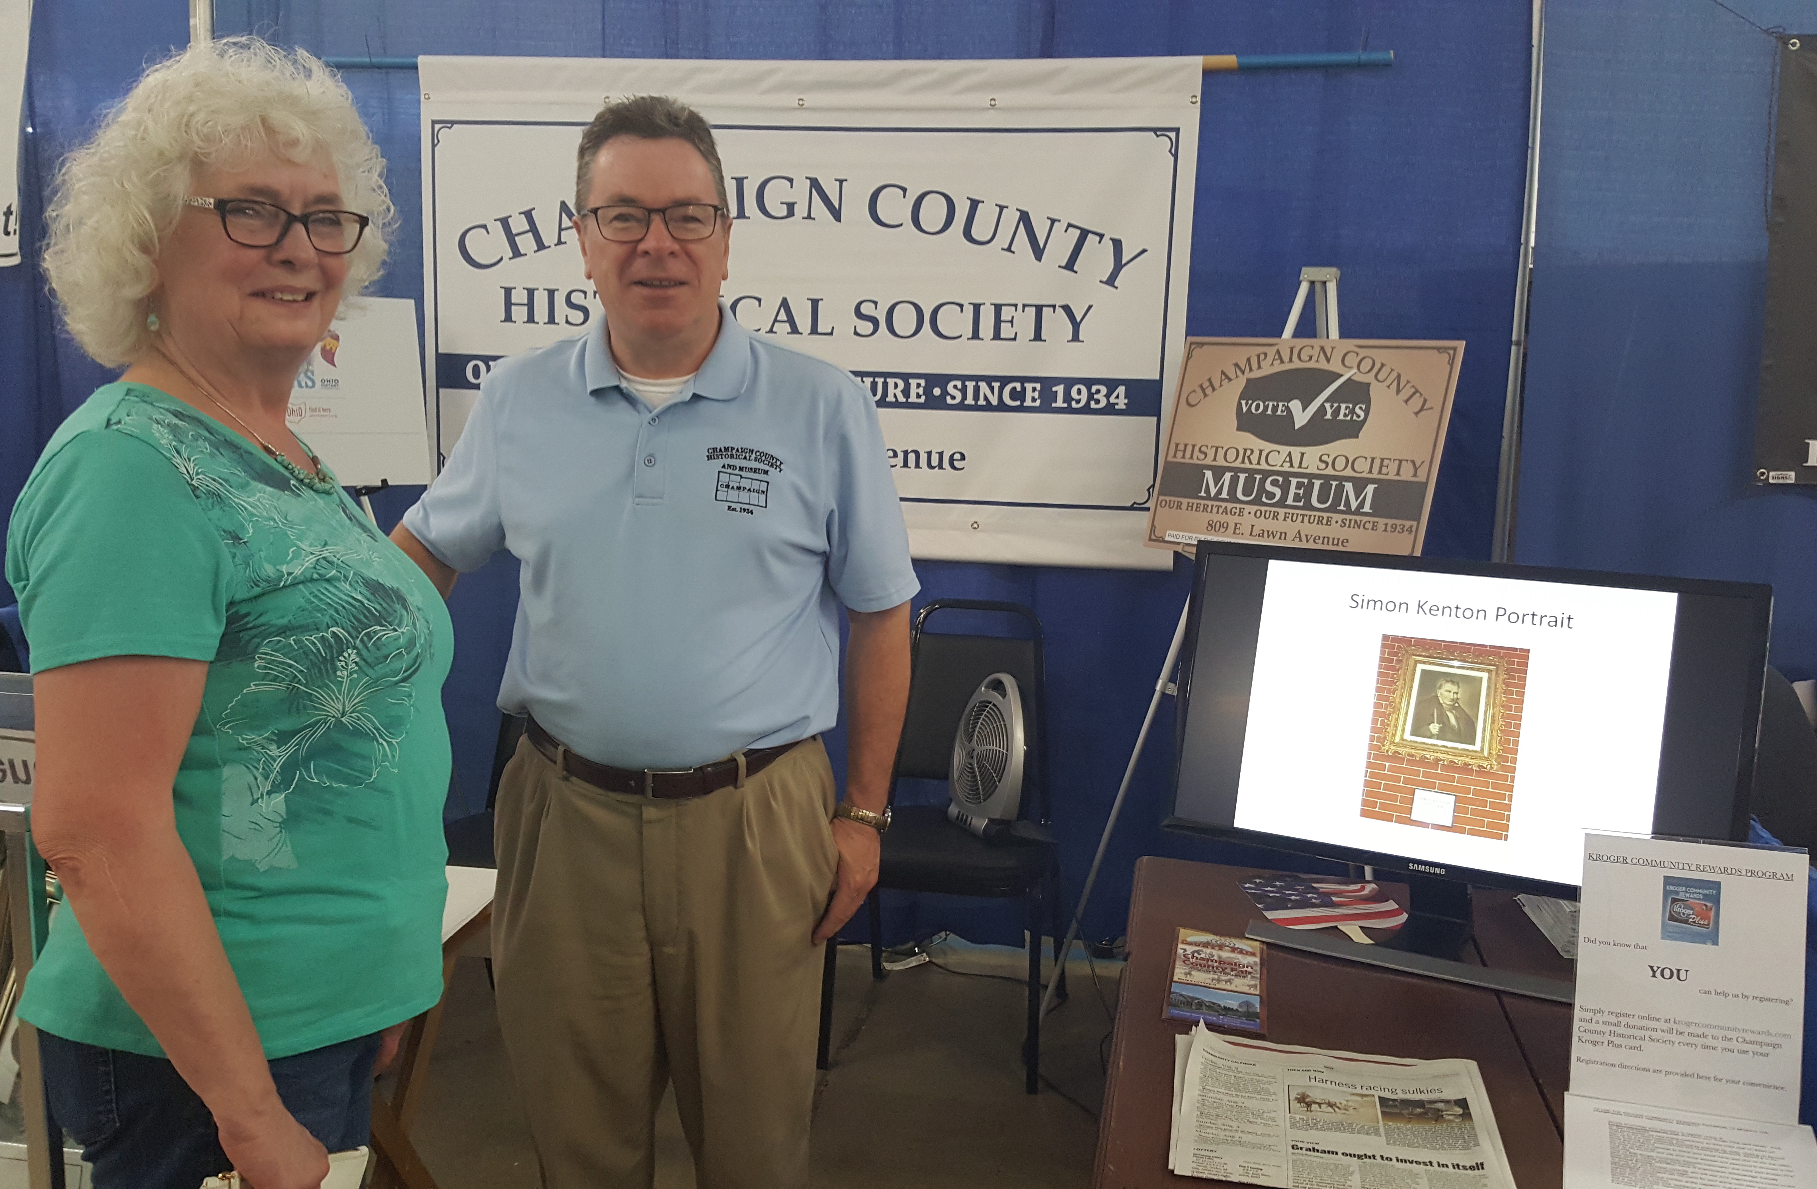
Pictured above is our Merchant’s Building booth. Included was a 42-slide Powerpoint presentation that scrolled continuously. Also displayed were artifacts pertaining to Addison White as well as the original print of the Emancipation Proclamation provided to Champaign County early in 1863. THANK YOU to the current and former board members who “manned” the booth in two shifts per day. Pictured on the right is VP Rob Pollock with visitor Karen Stickley Gibbs.

PRESIDENT’S UPDATE

We have worked hard to increase our presence throughout the county and people have noticed! If you have
not had a chance to take our 10-question survey on our website, please do so. We are receiving valuable input
and welcome more of the same. Moreover, we received many visitors at the fair and learned a lot from them.

A number of supporters weighed in on our levy campaign and suggested that many voters do not realize just how small the millage is. Others seemed to think that it will apply to all citizens, not just property owners. We’re listening and will highlight
3/10 of a mil

in our promotional materials and further explain that this equates to about
$10 per year

on a property appraised at $100,000.

More than ever, we need the support of all members to pass this issue and thus stabilize our museum operation. Contributions made to the CCHS Campaign Committee will be deposited in the First Central National Bank of St. Paris and may be sent to CCHS, P. O. Box 65, Urbana, OH, 43078.
As always, we thank you for your support. -Dan Walter
COMING EVENTS

During the week of Sept. 8 - 16, sites throughout the state normally not open to the public will be available for public tours. CCHS will host the event in Champaign County which will take place from 12-5 Saturday September 15.

Sites will include Christiansburg (Honey Creek Cemetery - tours at 1:00 and 3:30 - and Masonic Lodge/Marion Ross Museum), Mechanicsburg (1858 Meeting House/2nd Baptist Church), N. Lewisburg (Library/Friends Church, Coates’ 1830’s log cabin, Pottersburg Covered Bridge), St. Paris (Pony Wagon Museum, Fire Station - Horse-Drawn Pump), Urbana (Gloria Theater, Masonic Temple, Penn Rail Car, Urbana Country Club).

Bonus events will include a tour of the Gloria and showings of the film “A Walk With Simon Kenton” at 10 and 12. The Urbana Country Club restaurant will be open to the public for both lunch and dinner, and there will be an “after” event at the museum from 5 - 7 during which renowned Champaign County native, Scott Kirby, will entertain. Watch for further details as we publicize this important event!
Kiser Lake and the Kiser Family’s Impact on Champaign County - and Beyond
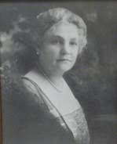
At 2:00 pm on Sunday Sept. 23 Bill Kremer, long-time Ranger at Kiser Lake State Park will present a program on the history of the Kiser Family, their industrial base, the creation of Kiser Lake, and their impact here and throughout the nation.

Thyrza Kiser
Civil War, Agriculture, and Politics: Three Stories.

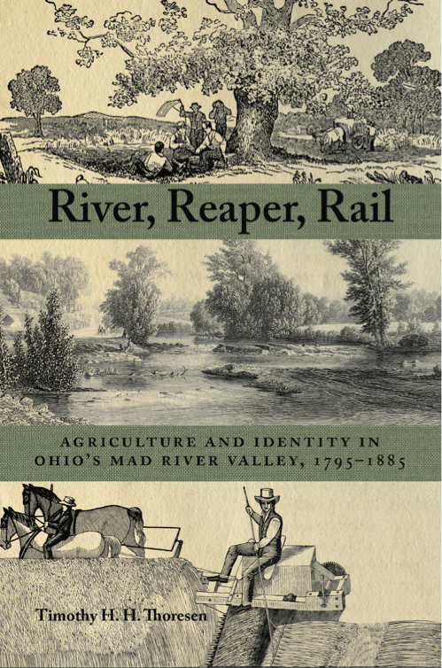
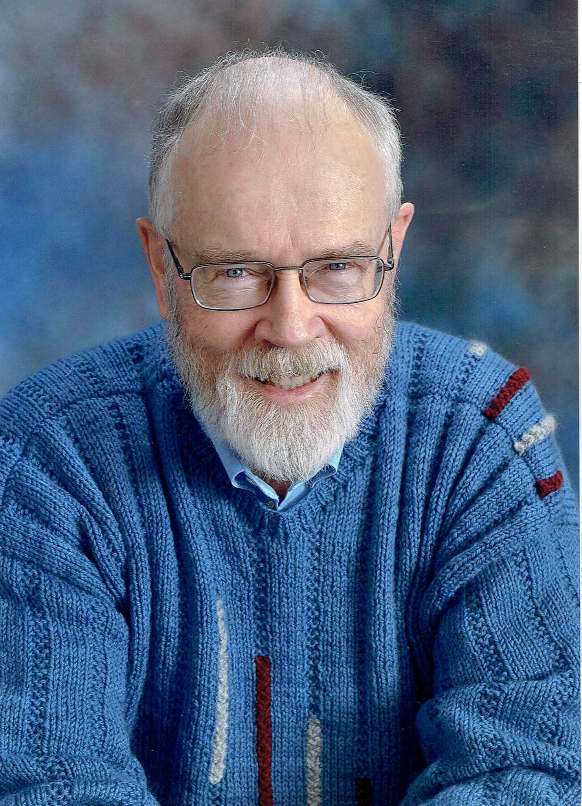
At 2:00 pm on Sunday Oct. 28 former CCHS board member, Dr. Tim Thoresen, will present a program based upon his new book River, Reaper, Rail. His presentation will include a number of stories about Champaign County not included in the book such as his account of the origination of the statue centered in Monument Square.

NEW MEMBERS

Jackey and David Arrington Russ and Donna Lou Erwin
Frank and Rosa Giampetro Dick Hatfield
Dorothy Lee Maze Hearing and Balance
Barbara Price Rick and Deb Stickley
Clint Thackery Vern Tobis
James Tolle Steve and Marilyn Woods

Invite your friends! www.champaigncountyhistoricalmuseum.org

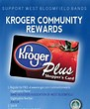

TO USE THE KROGER COMMUNITY REWARDS PROGRAM TO BENEFIT THE CHAMPAIGN COUNTY HISTORICAL SOCIETY:

- Register online at krogercommunityrewards.com and have your Kroger Plus card handy. Click on Sign In/Register.
- Most participants are new “online” customers, so click on SIGN UP TODAY in the ‘New Customer” box.
- Sign up for a Kroger Rewards Account by entering zip code, clicking on favorite store, entering your email address and creating a password, agreeing to the terms and conditions.
- You will then get a message to check your email inbox and click on the link within the body of the email.
- Click on My Account and use your email address and password to proceed to the next step.
- Click on Edit Kroger Community Rewards information and input your Kroger Plus card number. Update your information.
- Enter our NPO number (72139) or the name of our organization (Champaign County Historical Society).
- To verify you are enrolled correctly, you will see our organization’s name on the right side of your information page.
- REMEMBER, purchases will not count for our group until after members register your card(s).
- Do you use your phone number at the register? Call 877-576-7587 to get your Kroger Plus card number if you no longer have your card or have forgotten it.
- Members must swipe your registered Kroger Plus card or use the phone number that is related to your registered Kroger Plus card when shopping for each purchase to count.
- Fuel points will not be affected.
- Thank you! It’s not that difficult!

